Module 4 – Question 3
Question Name: Subtract the Product and Sum of Digits of an Integer
Platform: LeetCode
Programming Language: C
Problem URL: https://leetcode.com/problems/subtract-the-product-and-sum-of-digits-of-an-integer/
Problem Statement
Given an integer number n, return the difference between the product of its digits and the sum of its digits.
Input Format
A single integer n.
Output Format
Return the difference between the product of the digits and the sum of the digits.
Constraints
- 1 <= n <= 10^5
Sample Input 1
234
Sample Output 1
15
Explanation
Product of digits = 2 × 3 × 4 = 24
Sum of digits = 2 + 3 + 4 = 9
Result = 24 - 9 = 15
Sample Input 2
4421
Sample Output 2
21
Explanation
Product of digits = 4 × 4 × 2 × 1 = 32
Sum of digits = 4 + 4 + 2 + 1 = 11
Result = 32 - 11 = 21
Code Screenshot
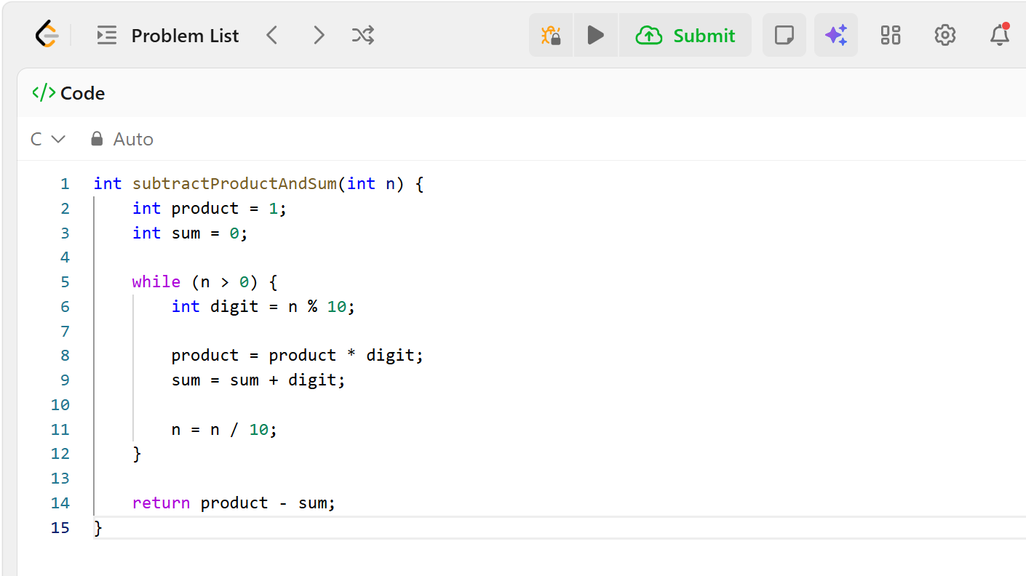Output Screenshot
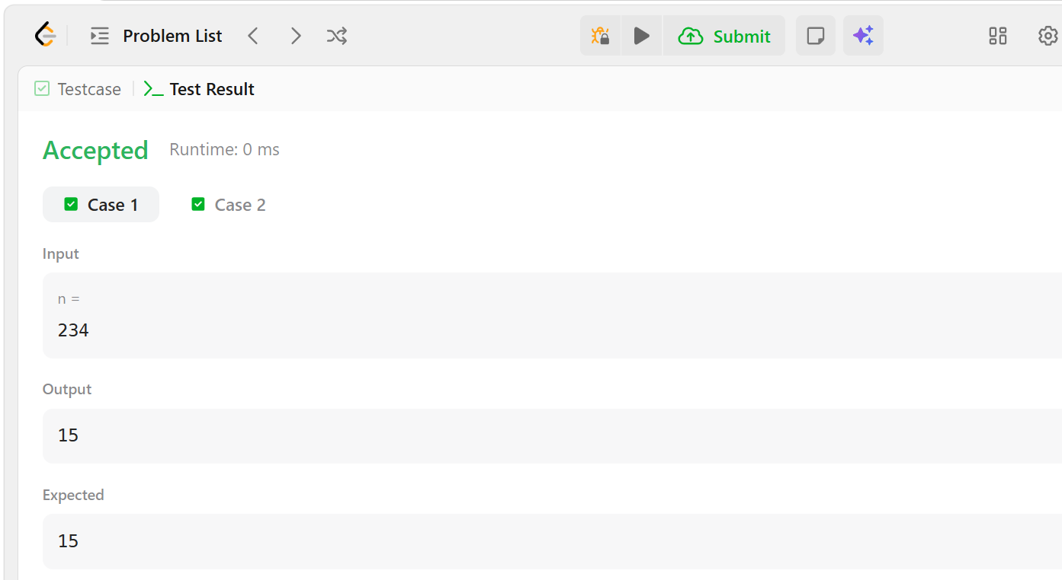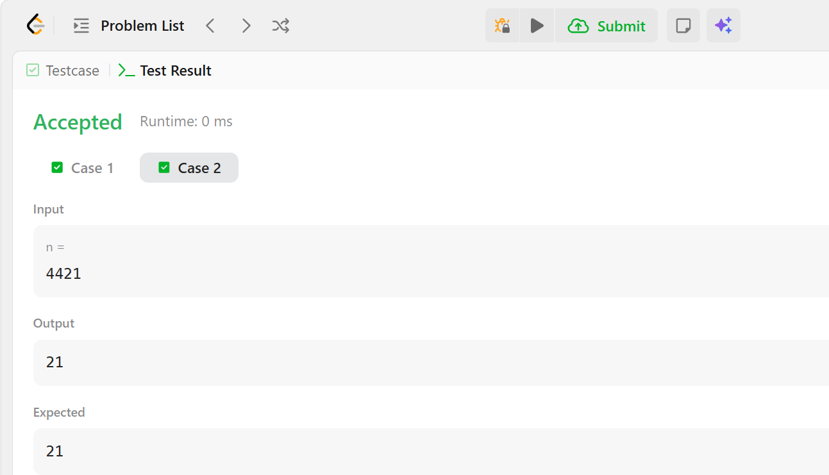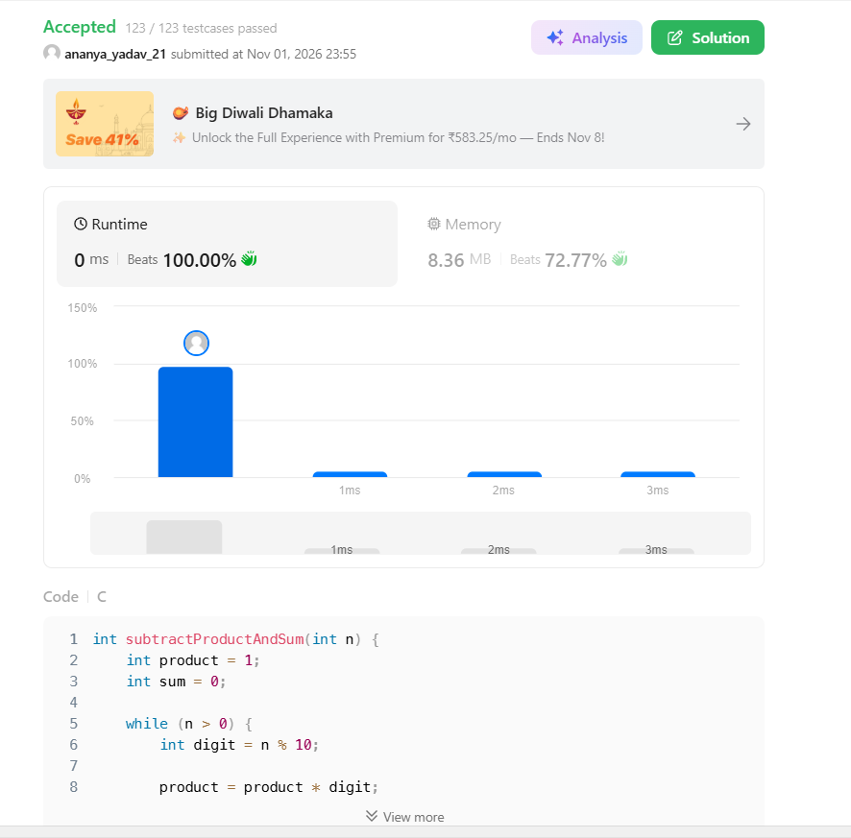Result
The program was successfully executed and submitted on LeetCode. All test cases passed, and the expected output was obtained.

